25 — Получение данных из интернета от 03.10.26 9ИС-360 Чайкин А.

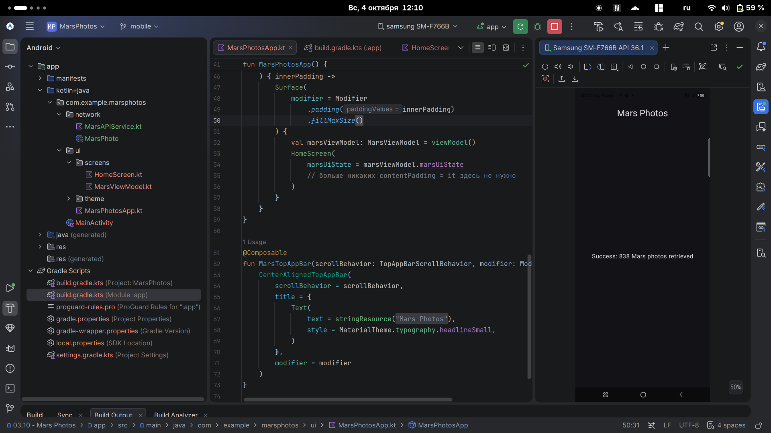
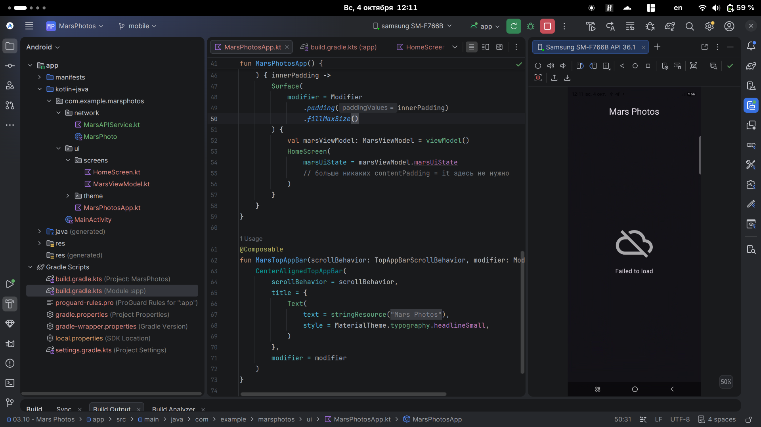
MarsViewModel.kt

package com.example.marsphotos.ui.screens
import androidx.compose.runtime.getValue
import androidx.compose.runtime.mutableStateOf
import androidx.compose.runtime.setValue
import androidx.lifecycle.ViewModel
import androidx.lifecycle.viewModelScope
import com.example.marsphotos.network.MarsApi
import kotlinx.coroutines.launch
import java.io.IOException
sealed interface MarsUiState {
data class Success(val photos: String) : MarsUiState
object Error : MarsUiState
object Loading : MarsUiState
}
class MarsViewModel : ViewModel() {
var marsUiState: MarsUiState by mutableStateOf(MarsUiState.Loading)
private set
init {
getMarsPhotos()
}
private fun getMarsPhotos() {
viewModelScope.launch {
try {
val listResult = MarsApi.retrofitService.getPhotos()
marsUiState = MarsUiState.Success(
"Success: ${listResult.size} Mars photos retrieved"
)
} catch (e: IOException) {
marsUiState = MarsUiState.Error
}
}
}
}

HomeScreen.kt

package com.example.marsphotos.ui.screens
import androidx.compose.foundation.Image
import androidx.compose.foundation.layout.*
import androidx.compose.material3.Text
import androidx.compose.runtime.Composable
import androidx.compose.ui.Alignment
import androidx.compose.ui.Modifier
import androidx.compose.ui.res.painterResource
import androidx.compose.ui.res.stringResource
import androidx.compose.ui.unit.dp
import com.example.marsphotos.R
@Composable
fun HomeScreen(
marsUiState: MarsUiState, // <-- ИЗМЕНЕНО: теперь принимает MarsUiState, а не String
modifier: Modifier = Modifier
) {
when (marsUiState) {
is MarsUiState.Loading -> LoadingScreen(modifier = modifier.fillMaxSize())
is MarsUiState.Success -> ResultScreen(
marsUiState.photos, modifier = modifier.fillMaxWidth()
)
is MarsUiState.Error -> ErrorScreen(modifier = modifier.fillMaxSize())
}
}
@Composable
fun LoadingScreen(modifier: Modifier = Modifier) {
Image(
modifier = modifier.size(200.dp),
painter = painterResource(R.drawable.loading_img),
contentDescription = stringResource(R.string.loading)
)
}
@Composable
fun ErrorScreen(modifier: Modifier = Modifier) {
Column(
modifier = modifier,
verticalArrangement = Arrangement.Center,
horizontalAlignment = Alignment.CenterHorizontally
) {
Image(
painter = painterResource(id = R.drawable.ic_connection_error),
contentDescription = ""
)
Text(text = stringResource(R.string.loading_failed), modifier = Modifier.padding(16.dp))
}
}
@Composable
fun ResultScreen(photos: String, modifier: Modifier = Modifier) {
Box(modifier = modifier, contentAlignment = Alignment.Center) {
Text(text = photos)
}
}

MarsAPIService.kt
package com.example.marsphotos.network
import com.jakewharton.retrofit2.converter.kotlinx.serialization.asConverterFactory
import kotlinx.serialization.json.Json
import okhttp3.MediaType.Companion.toMediaType
import retrofit2.Retrofit
import retrofit2.http.GET
private const val BASE_URL = "https://android-kotlin-fun-mars-server.appspot.com"
private val retrofit = Retrofit.Builder()
.addConverterFactory(Json.asConverterFactory("application/json".toMediaType()))
.baseUrl(BASE_URL)
.build()
interface MarsApiService {
@GET("photos")
suspend fun getPhotos(): List<MarsPhoto>
}
object MarsApi {
val retrofitService: MarsApiService by lazy {
retrofit.create(MarsApiService::class.java)
}
}

MarsPhoto.kt

package com.example.marsphotos.network
import kotlinx.serialization.SerialName
import kotlinx.serialization.Serializable
@Serializable
data class MarsPhoto(
val id: String,
@SerialName(value = "img_src") val imgSrc: String
)

